2021 03 16 How to understand Excel Joystick Piloting formulas and calculations Rev 0

1: It is important to keep in mind the ultimate goal of the Joystick Piloting Project: Being able to fully exploit ArduPilot for a real full size boat with 2 outboard engines:

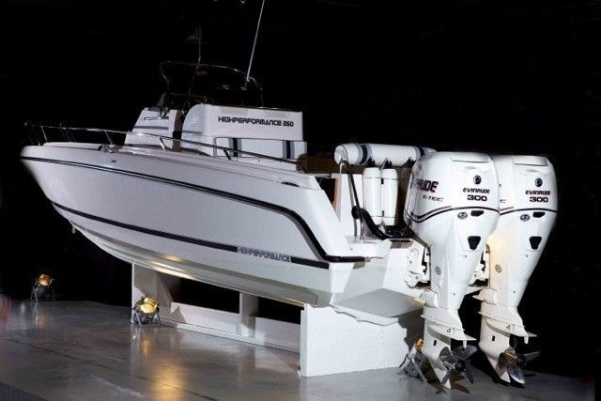

2: The referenced Excel calculations sheet is a necessary first initial primitive “crawl-before-you-can-walk” approach the high level mathematical simulations complexities that we are getting into. Here is our blueprint for setting up the calculations:

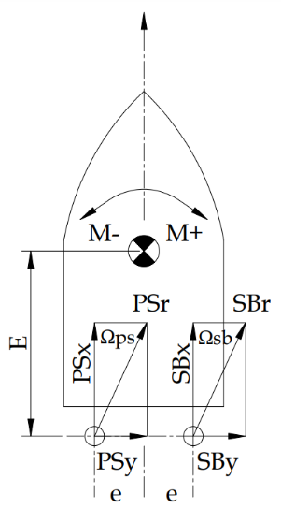

* PS Port Side (left side) engine with at steering angle Ωps, sitting at distance e from boat center line and distance E from CoG Center of Gravity.
* SB StarBoard (right side) engine fully independently operatable with same parameter set.
* Propeller force PSr ( resultant) and SBr are decomposed into the respective x and y components.
* Moment M at CoG being the resultant of all forces x length summarized into a M sum, that may end up in clockwise or counterclockwise direction.
* The inherent DRAMATIC limitation of outboard engines: Steering angle is max +/- 30 dgr maybe 40 dgr.

3: Regression analysis in Excel is valuable skill: Tab Range formula regression.

Eventually, to play with these formulas, it is smart to refresh how they actually work:

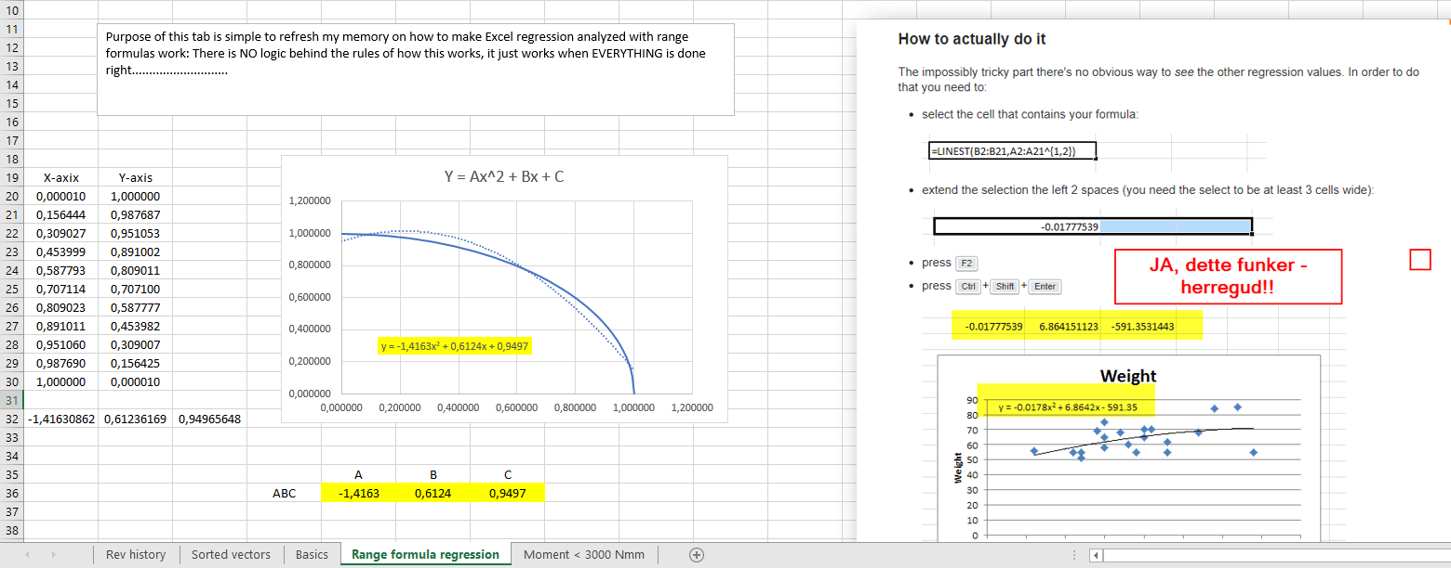

4: Tab Basic Section 1: General information

Collection of general information in preparation:

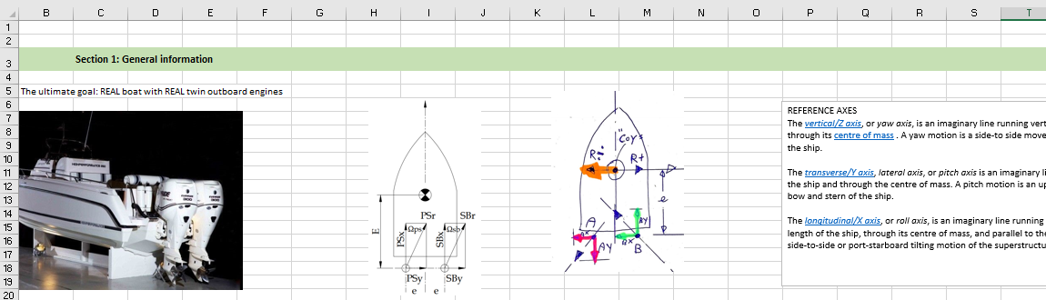

5: Tab Basic Section 2: Mapping of forces for RC boat 92 centimeter

This is just fake numbers imagined in my head as a starting point to build formulas. The actual forces required to pull the boat in different directions must be established by MEASURMENTS: Use a fish scale to pull the boat in different direction at different speeds to get real values

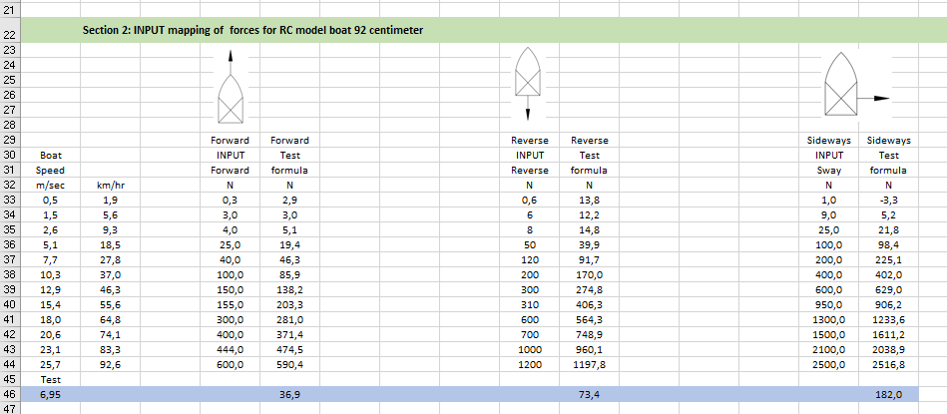

6: Tab Basic Section 3: Joystick mapping

For each position of the joystick, we want boat to travel at a specific speed in the direction.

The objective of this section is to map/translate/convert from joystick position to X/Y speed and thereby also required force. This work is not yet completed:

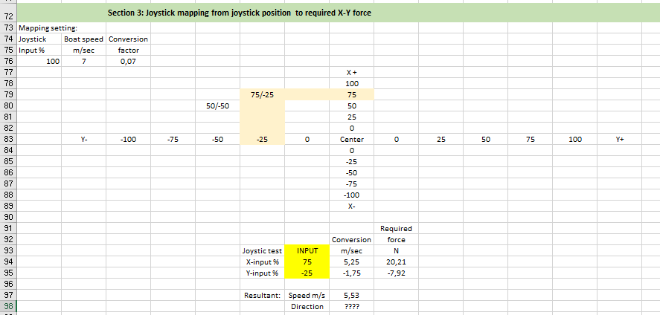

7: Tab Basic section 4: Engine mapping

The Newton N values are just imaginary values imagined by me as a starting point.

NOTE: Since I am using regression analyzis formulas directly connected to the subsequent calculations, any many update of the Newton input values is updating formula ABC values and all the subsequent formulas ( used in 10 000 rows of this spreadsheet…………….)

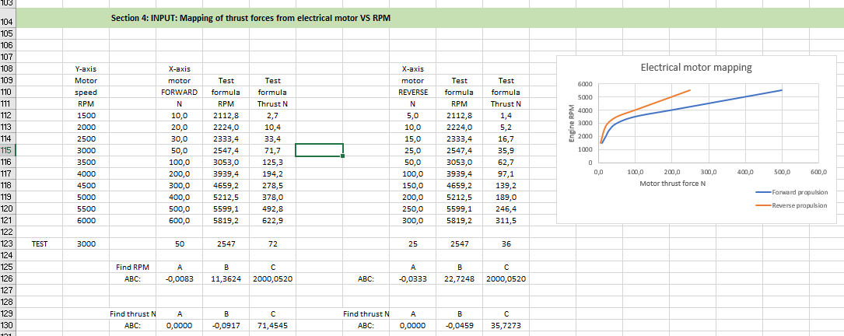

8: Tab Basic Section 5: Mapping of resultant forces AND moment for dual motors.

This is very the heavy work starts:

For 5 different engine RPM speed

For 9 different steering angles

Forward and reverse

= 5x 9 x 2 = 90 rows.

EACH of those rows are COMBINED with each of the 90 rows of the other engine

90 x 90 = 8 100 rows, mostly copy/pasted manually.

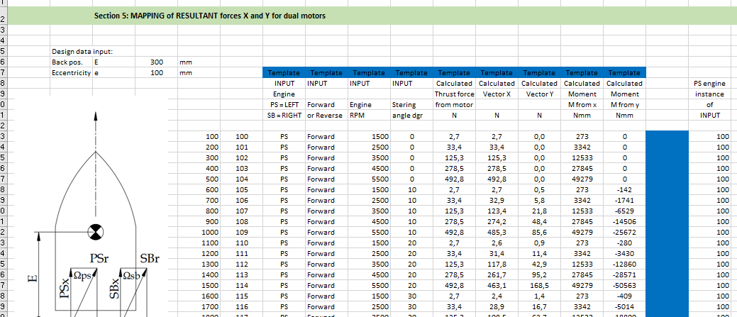

9: Tab Sorted Vectors

The complete Basic tab was copied into new tab for “Sorted Vectors” the sorted by resultant Moment around CoG.

What I am looking for, is what combinations of engine parameters allow boat to move strictly sideways while NOT rotating = I am looking for combinations where M < 3000 Nmm

Those sorted results are colored green here in Row AQ, and subsequently copied into new tab “Moment < 3000 Nmm”

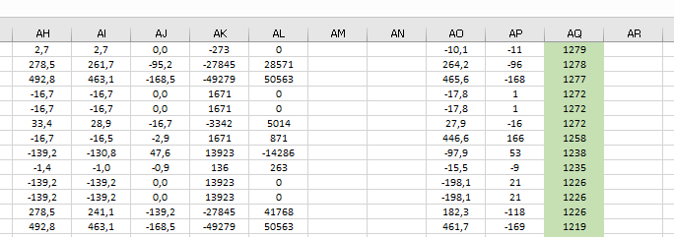

10: Tab Moment < 3000 Nmm

After being copied hereto, I again sorted, this time by column AC because I want to find largest Vector Y for smallest Vector Y = Moving boat sideways while NOT rotating boat.

My final pick is the dark blue highlight row of Vectory Y = 182 N

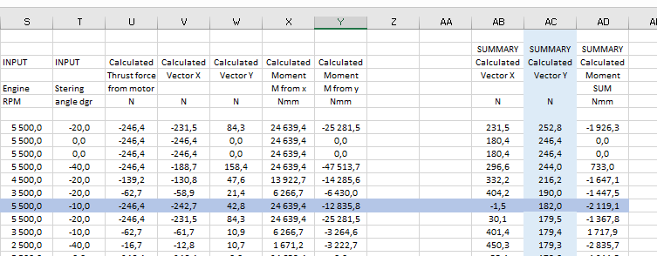

11: Going back to tab Basic Section 2:

Using Goal Seek to find which boat speed correspond to Vectjor Y force of 182 N I find that boat shall move sideways ( Sway) at a speed of 6,95 m/sec.

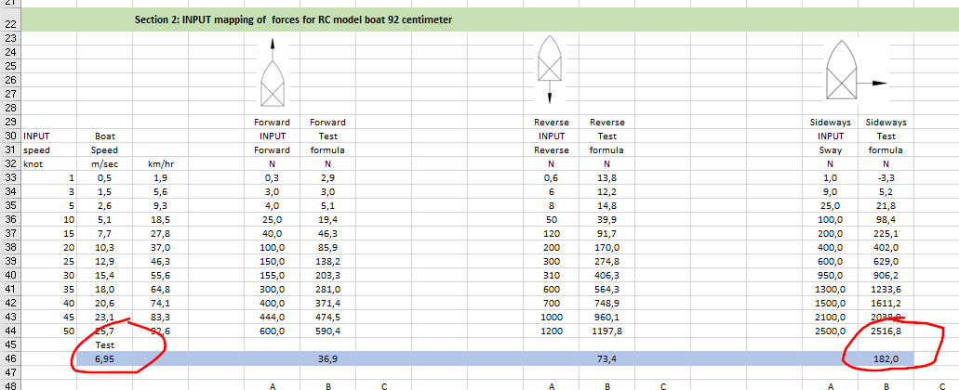

To make this happen, Port Side Engine must run Forward at 4500 RPM and at steering angle of +30 dgr:

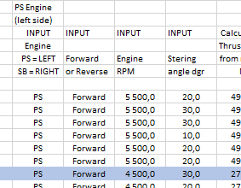

StarBoard side engine must run in REVERSE at 5500 RPM with steering set at -10 dgr.

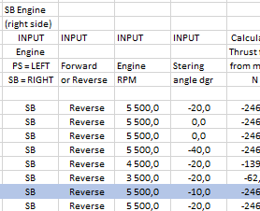

IMPORTANT: ALL ABOVE NUMBERS ARE FAKE IMAGINARY NUMBERS FOR TESTING of formulas ONLY. We must update for real value for the RC boat.

16 March 2021 Jørn.